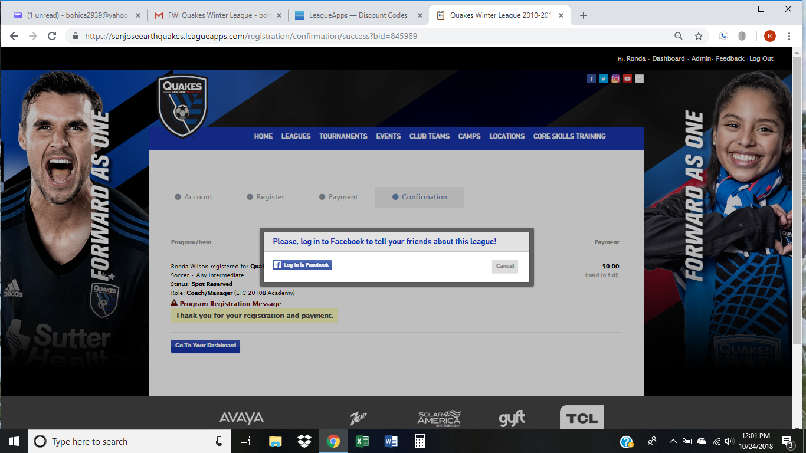
After payment – please click “Cancel” and then the “Go to Your Dashboard” blue button on the lower left-hand side of the screen to enter roster details.

From your Dashboard – scroll down to your team and click on “+Add Players”
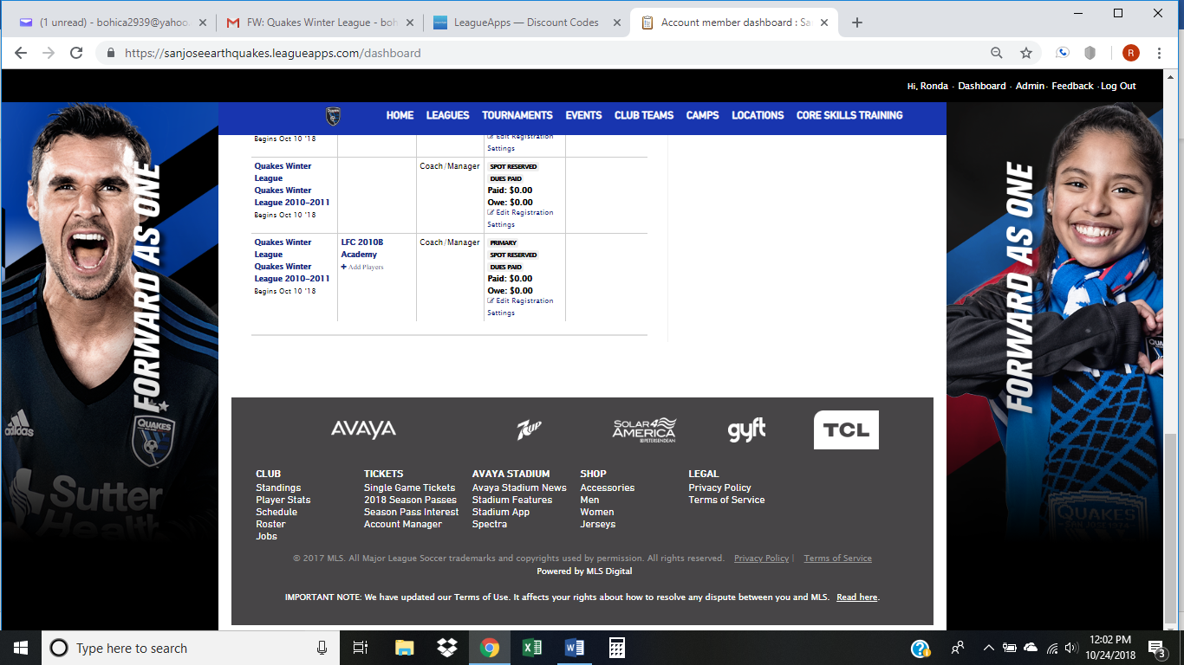

Input Player Name; Gender; Birthdate
Parent Name(s), Address, Phone# and email address. Save information and add next player
